

ITA0324-Mobile Computing

Name: A. Anusha Reg no:192472083

Slot: C Course Name: Mobile Computing

Experiment 3: Network Switching Subsystem Flowchart
Aim: To develop a flowchart depicting the operation of a Network Switching Subsystem (NSS) in a mobile cellular system.
Procedure:
- Open Figma and create a new design file.
- Create a frame for the NSS flowchart.
- Add a start symbol and a mobile user requesting a call.
- Add MSC, HLR, VLR, AuC, and EIR components.
- Connect the components using arrows to represent the call-processing sequence.
- Add decision points for authentication and call routing.
- Use different colors for each stage and arrange the flowchart clearly.

Output:
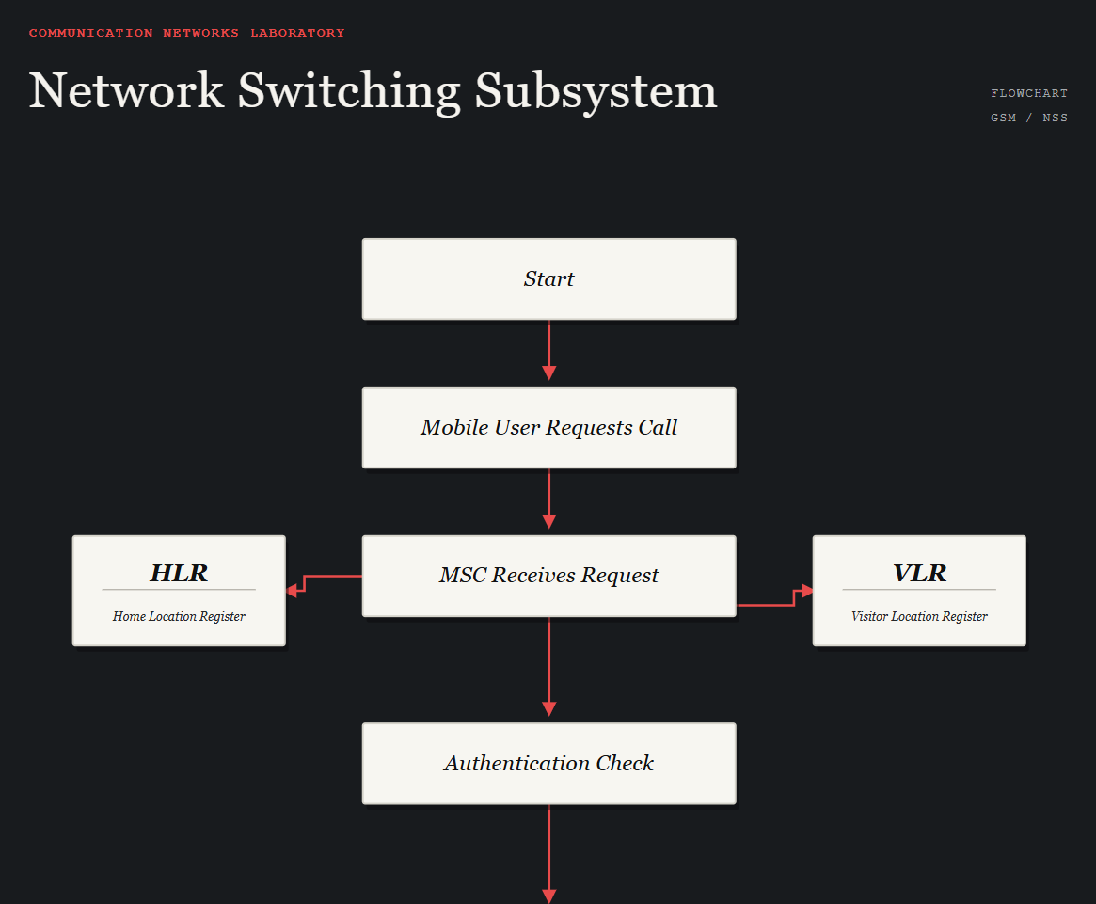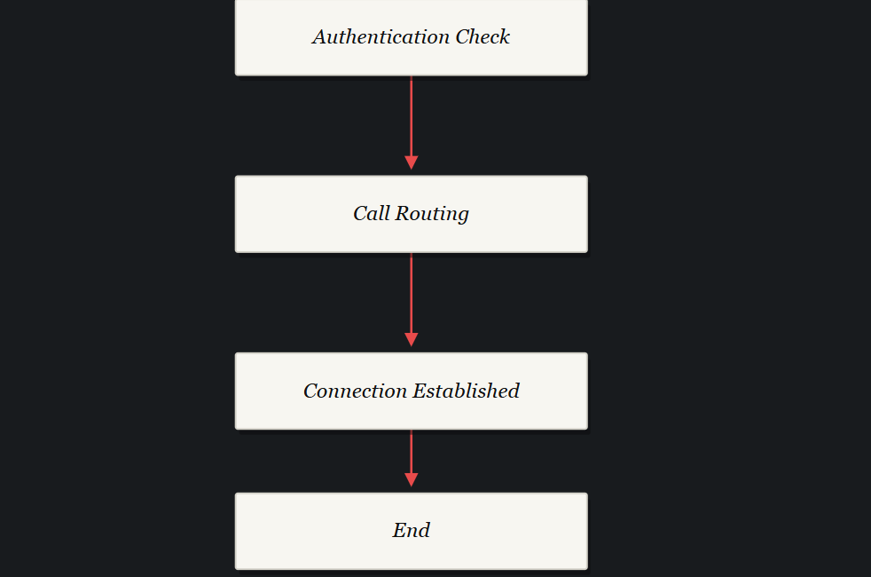

Result: Thus, a flowchart representing the operation of the Network Switching Subsystem was developed successfully using Figma.

